**Business Process Models for Higher Education Institutions: Can They Help in Selecting Teaching Technology for the “Digital Environment”?**

**Peter Canellis**

**Maxine Lubner**

**Vaughn College of Aeronautics and Technology**

**Introduction**

It is difficult, if not impossible, to discuss more effective course development and teaching techniques without also talking about the technology support tools that go with them. Indeed, this can be said of virtually all efforts undertaken by a higher education institution (HEI) to develop, deliver and support quality education.

This paper will argue that technology choices can be made much more effectively when guided by the use of a business process model.

Clearly documented business process models help commercial organizations to define precisely how they operate. Identifying business processes and understanding which ones deliver the essential goods or services that clients value ( “core” processes) is a prerequisite to defining key performance indicators (KPI’s). Understanding KPI’s, in turn, enables operationalization of components of continuous improvement practices. Following this approach means that correct applications of process models are necessary enablers of quality management systems.

Despite proven effectiveness in the private sector (especially when developed and correctly applied in conjunction with data models), this approach has not been embraced by the higher education community (Elmuti & Kathawala, 2000; Seethamraju, 2012). Doing so would help higher education institutions (HEI’s) to:

* Describe how work is really accomplished
* Identify core processes
* Support development of process metrics and continuous improvement
* Support choosing appropriate technology to help effect continuous improvement.
* Facilitate communication among departments and individuals
* Control or reduce administrative costs

These benefits should accrue to both the administrative side of a Higher Education Institution’s (HEI’s) operations, as well as to their core operations of educational program design, development and delivery. Numerous studies have supported the widespread acceptance that business process modeling application and standardization helps businesses to improve their performance, increase product quality, enhance market success, reduce process time, and decrease costs (in Muenstermann, Alexander, Laumer & Eckhardt, 2010). Similar administrative benefits should result from applications of business process modeling to HEI’s.

Additionally, business process modeling will help the instructor in his or her four roles of subject matter expert, course designer, class manager, and student coach, to select and apply technology.

Effective technology choices will support delivery of improved or altered learning experiences with consistent quality in both the traditional and the “extended” classroom (Campbell, 2000).

Examples of these technology decisions are applications to deliver content from multiple sources using event-driven web searches, and biometrics to ensure testing authenticity and integrity in the online environment (Campbell, 2000). Pedagogical practices would also improve, as for example, web-based instruction requires a structured presentation design to help students progress logically through the content and prevent their becoming overwhelmed or disoriented regarding the amount of information available via the internet. Similarly, faculty are relieved of course delivery tasks, but their content development efforts must not be overlooked (Campbell, 2000). Real applications of business process modeling may also help to answer McFarlane’s (1995) call to better integrate traditional business faculty and their academic practices with more of the business practices and ethics that are useful to the business community.

**Benefits of a Process-based Organization**

Looking at an institution’s organization chart provides general information about reporting hierarchies and where general areas of functional expertise are domiciled. For example, people in an Accounting department have knowledge of Accounts Payable, Accounts Receivable and General Ledger, while those in a Sales department understand client relationship management. This is important information, but it does not describe how work actually gets done. The limited utility of the “org chart” is even more evident when work processes cut across two or more departments: and most work processes do!

Process-based organizations enjoy the following benefits:

* Work process descriptions are simple and direct
* Work is described in the way that it is actually performed
* Key performance indicators (KPI’s) of process efficiency and effectiveness are easily formulated
* A foundation is established for continuous improvement of output

**Process-based Management: History**

Process-based management developed in the mid-1980’s after Dr. Michael Porter’s paper on the subject appeared in the Harvard Business Review (Porter, 1979; 2008).



Since that time, many variations on the theme have been created but they all ultimately get down to Dr. Porter’s basic concept: There are a group of core processes for which an organization’s clients are willing to pay, and these are supported by other processes that are essential but do not have a direct or immediate impact on the client.

Examining this concept in more detail, we find that an organization adds value (i.e., the organization’s “Operations”) to input factors (provided by “Inbound Logistics” processes) and subsequently provides those value-added products and services (via “Outbound Logistics” and after-market “Services”) to the market.

**Development and Application of Process Models**

Building upon the basic concepts, we can develop generic process models for manufacturing and for services organizations. The big difference between these two generic models is that manufacturing aligns more closely with the “classic” model’s definition of “core processes” discussed above, while the services model’s core processes can be defined by two categories: Service Development and Service Delivery.

**Adaptation of the Services Model to Higher Education Institutions**

Higher Education Institutions (HEI’s) can be considered as a specific type of services organization. Accordingly, we can modify the generic services model and identify “Program Development” and “Program Delivery” as the two major categories of core processes.



It is important to bear in mind that defining the HEI’s operations from a process perspective is “descriptive” rather than “prescriptive”. Each HEI will define its core process somewhat differently. What is most important is not how the model is structured but, rather, that all of the processes be captured. For example, an HEI may choose to recognize “Program Design” as separate from “Program Delivery”. Another alternative (among many) would be to recognize a second tier of core processes at the course level rather than embedded within a program.

Another example would be how each institution defines “support services”. Here, one may include programs associated with student life, remedial academic activities or support for course and program assessments.

**The Profit Pyramid**

How can we link process management to technology selection? This question may be answered by considering a related concept that we will call “The Profit Pyramid”.

The “Profit Pyramid” is a concept that complements the process model. As illustrated in the figure below, a profitable organization creates and sustains its profitability by providing satisfaction to customers through provision of some assortment of products and services. These products and services are provided through the execution of the organization’s core processes. These processes are, in turn, supported by investment in people, information systems and capital assets.

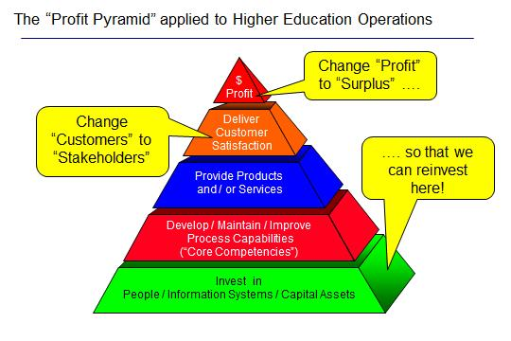

Also as illustrated, we can modify the Profit Pyramid to accommodate non-profit organizations. Possible modifications would be to change “Profit” at the top of the pyramid to “Surplus”, and to change “Customers” (at the second level from the top) to “Stakeholders”. If an HEI can generate a surplus, it will have funds to invest in people and technology (i.e., information systems and capital assets) with the objective of improving competence in processes that are “core” and “critical”.

“Core” processes may or may not be “critical”. A core process is one for which a client or customer pays an organization for delivering. For example, one core process for an HEI would be “Course Delivery”. In comparison, “Course Design” or “Course Development”, while certainly critical, may not be considered by an HEI to be core. The difference is that a process that is both “core” and “critical” must be kept in-house under direct control of the organization, while one that is “critical” but not “core” could be outsourced to a competent and trusted provider.

The distinction between “core” and “critical” processes is illustrated in the figure below.

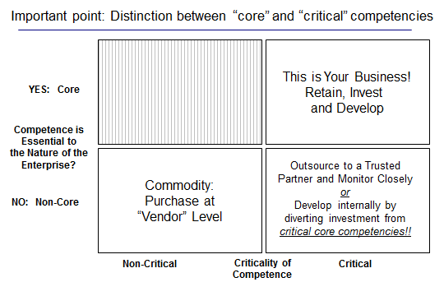

With a clear understanding of the organization’s processes, including strategic rather than political decision making, prudent and cost-effective choices can be made concerning the procurement and application of technology to the objective of organizational success (Dean & Sharfman, 1996).  This links process management to technology selection.

To this point, we have discussed process modeling along with the “Profit Pyramid” which links technology selection and investment to process improvement. We have also distinguished between “core” and “critical” processes. This distinction will influence technology selection and procurement.

However, before we can make intelligent and informed choices about what technology to apply in the “online” or “digital” teaching environment, we need to define what these terms mean to us as they will differ among individuals and institutions.

One approach is to categorize the environment according to the timing of an instructor’s content delivery relative to when the students receive it. Timing, therefore, can either be synchronous or asynchronous. Another category might be location of content delivery to students relative to the location of the instructor.  The illustration below summarizes these distinctions.

The usual conception of the “Digital Environment” is one of asynchronous timing of delivery, with the instructor physically remote from the students. However, increasing need for flexibility means that we must prepare for any combination of timing and location of content delivery.

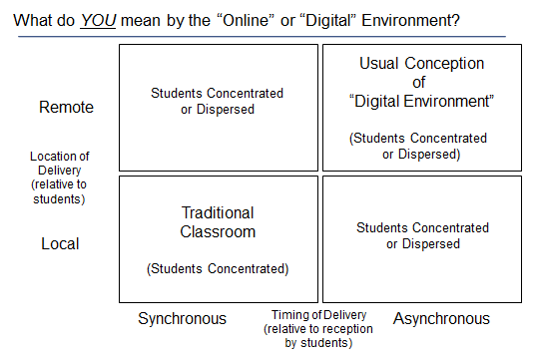

With the above determined, we can choose productivity applications to enhance the learning experience. These applications will, depending upon the specific circumstances, also require some types of supporting or “enabling” technology for:

* Data collection and capture
* Data and information storage
* Presentation and reporting
* Data and information communication
* Information systems management

This taxonomy for information systems is illustrated below in an “explosion” of the detail in the bottom tier of the Profit Pyramid.

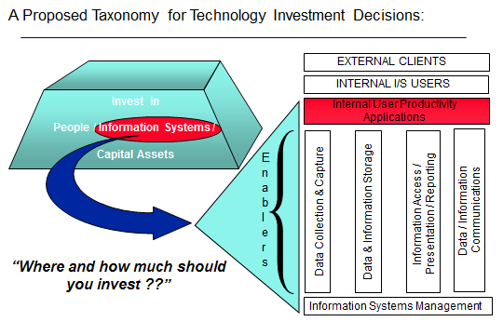

With such a wide variety of technology to choose from, we also need a guide for finding our way through the “noise” of technology selection. An approach to this issue might be called a “Technology Filtration System”, whereby various technologies are considered at three levels:

* Awareness – What’s out there in the technology universe? This can be accomplished by feeding information on all technologies to an educational technology support group at the school. In this way, the group can act as a clearing house for the school and provide input to a technology steering committee that would consider further investigation.
* Usability – Are we ready for this technology? This question addresses some of the “softer”, personality-related aspects of technology selection, for example:
  + Will the technology change our processes?
  + Do we have any technophobes who will be overwhelmed by it?
* “Do-ability” – Can we introduce the technology successfully? Here, we answer questions such as:
  + Can we afford the cost?
  + If we can afford the cost, do the associated benefits justify the expense?
  + Can we run a successful pilot program?

We cannot introduce technology into our operations for its own sake. There must be a clear strategic intent associated with any technological initiative. We believe that strategic intent to be the assurance of high and consistent instructional quality across all delivery scenarios.

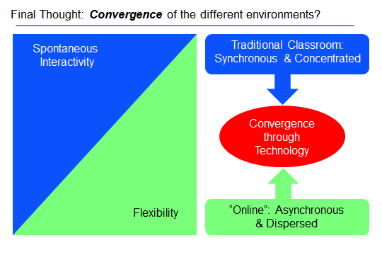

**Next Steps?**

If this process-focused approach to education is taken, it can be implemented in four steps:

1. Create the Process Model – it will be different for every institution
2. Identify Core Processes and Metrics – this will guide investment decisions
3. Select Appropriate Technology – we want to avoid buying “shelf-ware” that’s expensive and doesn’t get used
4. Implement, Test and Improve – to ensure that objectives are met and that technology is used to its maximum potential

Using this approach will enable effective and efficient technology selection. Examples are provided in the table below.

|  |  |  |  |  |  |
| --- | --- | --- | --- | --- | --- |
|  | **Event Management** | **Video-**  **Conferencing** | **Biometrics** | **Electronic Surveys** | **Learning Management**  **Systems** |
| **Design Courses** |  |  |  | Gather feedback for improvement |  |
| **Deliver Content** | Provide current content based on keywords | Bring “physical” classroom feel to the “virtual” classroom |  | Gather feedback for improvement | Provide platform for course delivery |
| **Manage Classes** | Manage deadlines | Bring “physical” classroom feel to the “virtual” classroom | Ensure student identities for attendance and testing | Gather feedback for improvement |  |
| **Coach Students** |  |  |  | Gather feedback for improvement | Gather feedback for improvement |

**Summary**

Unlike an organization chart which indicates “departments” of professional expertise (e.g., Accounting, Human Resources, etc.), a process model captures how work is actually performed. Work processes usually cut across multiple departments or areas of professional expertise, and are not confined to “departments”.

Finding ways to create common, shared definitions of equipment, procedures and goals, as well as deciding on processes that will operate in the same manner in all locations, helps to facilitate communication, and promotes efficiency, reduces waste and redundancy, and facilitates flexible cooperation, regardless of the size of the departments or HEI concerned.

Key performance indicators (KPI’s) serve as operational metrics for quality and continuous improvement while also representing process model components. As illustrated in the “Profit Pyramid”, linking processes with their respective KPI’s will make the selection and investment process for supporting technology more effective.

When applied by a HEI, a process model also helps to support the accreditation maintenance process, which is the essence of quality management for an academic institution. Choosing technology wisely will therefore support accreditation from a process and quality management perspective.

It is also important to note that the process model can (and should) be extended to include the administrative side of the school’s activities to support process improvements in areas such as Registration, Billing and Facilities Management. Faculty would have the opportunity to further their own professional development as they observe the implementation of a business process model in their institution at the ‘enterprise’ level (i.e., across all operations)

Applications to administrative decision making and operations within HEI’s is an area suggested for further research

**References**

Campbell, J. A. (2000). Using internet technology to support flexible learning in business education.*Information Technology and Management,1* (4), 351. Retrieved from http://search.proquest.com/docview/194516771?accountid=30591

Dean, J. W., & Sharfman, M. P. (1996). Does decision process matter? A study of strategic decision-making effectiveness. *Academy of Management Journal,39* (2), 368. Retrieved from <http://search.proquest.com/docview/199815374?accountid=30591>

Elmuti, D., & Kathawala, Y. (2000). Business reengineering: Revolutionary management tool, or fading fad? *Business Forum,* 25 (1), 29-36. Retrieved from <http://search.proquest.com/docview/210241710?accountid=30591>

Macfarlane, B. (1995). Business and management studies in higher education: The challenge of academic legitimacy. *The International Journal of Educational Management, 9* (5), 4. Retrieved from http://search.proquest.com/docview/229143831?accountid=30591

Muenstermann, B., Alexander, v. S., Laumer, S., & Eckhardt, A. (2010). The performance impact of business process standardization: HR case study insights. *Management Research Review,* *33* (9), 924-939. doi:http://dx.doi.org/10.1108/01409171011070332

Porter, M. E. (March–April 1979).  How competitive forces shape strategy. *Harvard Business Review*, 57, (2) 137–145.

Porter, M.E. (2008). (On Competition, Updated and Expanded Edition.) Boston, MA. The Harvard Business Review School Publishing.

Seethamraju, R. (2012). Business process management: A missing link in business education. *Business Process Management Journal*,*18* (3), 532-547. doi:http://dx.doi.org/10.1108/14637151211232696